Contents

List of Tables 2

Research Question 3

Data Collection 3

Hypothesis 4

Testing Hypothesis 5

Male Activists 5

Female Activists 13

References 26

# List of Tables

Table 1: Tweets (male activists) 5

Table 2: Sentiment Analysis of Tweets Containing the Keyword (male activists) 6

Table 3: Average Sentiment Percentages (male activists) 6

Table 4: Average Sentiment Score for Women Education (male activists) 7

Table 5: Analysis of Sentiment Comparisons (male activists) 9

Table 6: Analysis of Sentiment Comparisons (male activists) 9

Table 7: Tweet (female activists) 13

Table 8: Sentiment Analysis of Tweets Containing the Keyword (female activists) 14

Table 9: Average Sentiment Score for Women Education (female activists) 15

Table 10: Analysis of Sentiment Comparisons (female activists) 15

Table 14: Tweet (Taliban officials) 20

Table 15: Frequent Words (Taliban officials) 22

List of Figures

Figure 1:Sentiment Distribution (male activists) 6

Figure 2: Average Sentiment Percentages (male activists) 7

Figure 3: Average Sentiment Score for Women Education (male activists) 8

Figure 4: Most Frequent Words (male activists) 10

Figure 5: Time Series (male activists) 11

Figure 6: Tweet Frequency Time Series (male activists) 12

Figure 7: Word-cloud (male activists) 12

Figure 8: Sentiment Distribution (female activists) 14

Figure 9: Frequent Words (female activists) 16

Figure 10: Time Series (female activists) 17

Figure 11: Tweet Frequency (female activists) 17

Figure 12: Word-cloud (female activists) 18

Figure 13: Sentiment Distribution (Taliban officials) 21

Figure 14: Frequent Words (Taliban officials) 22

Figure 15: Time Series (Taliban official) 23

Figure 16: Tweet Frequency (Taliban officials) 24

Figure 17: WordCloud (Taliban officials) 24

Introduction

This research will examine the tones of the tweets posted by Afghan people, more specifically activists male and female, and Taliban officials, which currently rule Afghanistan. The topic of women’s education is presented in this study. The goal is to analyze the tweets of activists as well as the officials to gauge their level of support for women’s education. In this analysis, we look at the sentiment distribution across several topics connected to women’s education and compute the percentage of positive tweets from women. Descriptive data are included, as well as a chi-square test of independence and a comparison of sentiment ratings across sexes and those between activists and government officials/employees. The study wraps up with a review of the most popular phrases and terms that were found in the tweets.

In nations like Afghanistan, where women’s access to education has been severely restricted, this is an especially pressing issue. To better understand the feelings and level of support for women’s education among activists and officials in Afghanistan, this analysis focuses on tweets written by both sides. We hope to learn more about these activists’ including officials’ thoughts and feelings by conducting sentiment analysis on their tweets.

# Research Question

This study aims to examine the role that gender plays in Afghans’ views on women’s educational opportunities. The research question to be answered is: To what extent does gender, controlling for political inclination, affect people’s perception of women’s access to education?” The study uses Twitter data to discover if there are any gender-based trends or disparities in how people feel about lifting the restriction on women’s education. It stresses the necessity of destroying oppressive systems to realize gender parity. Data was gathered from Twitter, a widely used social media platform, and analyzed using content analysis techniques to see how people feel about the topic. The study attempts to illuminate the complexity of gender and its role in forming attitudes regarding women’s education by investigating patterns and trends in people’s perspectives. The findings will help educated people and those fighting for gender equality in the classroom better understand Afghan women’s obstacles and inequities while trying to get an education.

# Data Collection

The study has individually collected the Tweets. There are three different approaches to recognize the activists, to fetch their tweets. First one, the researcher has joined the Afghan Twitter spaces, to recognize them from there. The second one, through google, we can find them on google with their background. The third one is, activists have been frequently invited by Afghanistan’s TV, there are several TV channels which has hundreds of followers and views inviting activists in daily bases. E.g., “[TOLOnews](https://twitter.com/TOLOnews), [ArianaNews](https://twitter.com/ArianaNews_)_”

For the Taliban officials, we have single approach, which is “[Zabehulah_M33](https://twitter.com/Zabehulah_M33)”, “Official Twitter Account of the Spokesman of Islamic Emirate of Afghanistan, Zabihullah Mujahid”. This account is the official account of Taliban spokesman, and he has followed other officials we can find them easily on his followers. Also, we did the same thing for “[mobeenkhan1231](https://twitter.com/mobeenkhan1231)” which a famous person on social media, Mobeen is an active member of the Taliban and most of the official has followed him.

To analyze the data researcher have taken sample which consists of 54 different Twitter users, whether its activists are the Taliban, but the number of tweets could be different, dependent on the users how active they are. The duration of data collections starts from 2021, December, 01 to 2023, March, 30.

# Hypothesis

**H1:** Women are more likely to have positive sentiment on women’s education or support women education compared to men. The idea behind this hypothesis is that women may have a more nuanced grasp of the negative effects of restrictions on their ability to proceed with their education and, therefore, be more vocal and disagree with the ban on education. Historically, women in Afghanistan, dominated by male society, face serious obstacles to gaining an education and engaging in society and politics. Due to structural gender inequities, Afghan women have suffered disproportionately from restrictions on their educational ability. They know from personal experience how prejudice and other educational obstacles may limit one’s options in life. Therefore, it is reasonable to assume that women may be more likely to oppose the ban on women’s education because of their experiences. Poverty and social inequality are both pervasive issues in Afghanistan. Because of these obstacles, the educational opportunities for women are pitiful. There have been great restrictions on women’s education during the past four decades. Women endured unacceptable policies from 1996 – 2001; they were not allowed to proceed with their education and could not participate in politics to decide their future. The researcher mentioned earlier that Afghan women have historically experienced restrictions on education, they faced discrimination in education because of their gender, and they were considered inferior in the country. Thus, we can say that it’s a group of solidarity today. Women have more positive sentiments and support women’s education.

**H2:** Those who involved in activism are more likely to have more positive sentiment on women education compared to those involved in government. It is expected that activists are more likely to support women education that those affiliated with the government. This hypothesis implies that those who engage in activism, such as those who fight for educational reforms or work to advance women’s rights, are more likely to hold positive views and show significant support for women’s education. Those who work in government, whether as policymakers or government employees, may be less likely to have a good attitude about women’s education. This hypothesis suggests that taking an activist stance significantly impacts forming and encouraging constructive worldviews and advocacy initiatives aimed squarely at improving educational opportunities for women. It also hints at a potential divide between activists and government employees in worldviews, priorities, and strategies. It is clear that there is a need for more research and study into the complex interplay between activism and government participation in molding attitudes about women’s education. Insight into the myriad factors influencing public support for women’s education can guide policies and activities to expand women’s access to education.

# Testing Hypothesis

To test our hypothesis, we have used content analysis with sentiment analysis (Evans & Clark, 2015). Along with chi-square, which evaluates the consistency between an observed percentage and theoretical predictions; test for statistical significance between two variables often representing nominal or ordinal levels of measurement (Lewis & Burke, 1949), also, it is common practice to use cross tabulation (crosstab) as an analysis method to compare the outcomes of one or more variables with those of another. Also, we have labeled our data using five different keywords, which are related to the study, and frequently appears on tweets, which are 'education', 'school', 'university', 'women', 'girl', if any of these keywords appear on tweets it denotes with one (1) if not its zero (0). Basically 1 means the tweet related to one of these keywords if not the tweet about something else, which we call it as a neutral tweet, also, we remove tweets like “beautiful women”, or “good school”, these tweets does not relate to our study, unless the tweets talk about current topic, such as “women ban education”, or “girls cannot go to school”, the labeling process done by machine. Also, one keyword which we used is “women education”, with this keyword we are able to find the exact tweet which is related to women education and help as to get a good result of based on the tweet, because the keyword clear and related to women education.

# Male Activists

The first result in this section, which we have illustrated, belongs to the male activists. The study found 3,914 negative tweets, 5,180 positive tweets, and 8,307 neutral tweets in the dataset. The study uses sentiment measurements as a starting point for investigation. Table 1 shows the male activist’s tweets regarding women's education. This is a clean tweet after removing symbols, punctuation, and stop words. These are just a few samples we demonstrated in the format of clean and unclean tweets. The unclean tweets are the original; the clean ones are after being processed by the machine.

|  |  |
| --- | --- |
| Unclean | Clean |
| Unfortunately, the current problem of women's education and work in the country is very serious, sad and in the twenty-first century gender apartheid... | unfortunately, current problem women education work country serious sad twenty first century gender apartheid |
| Women in Afghanistan after the return of the Dark ages—Taliban rule. | women afghanistan return dark ages taliban rule |
| "The Taliban banned women's education in Afghanistan on the order of Pakistan," claims Hamid Karzai. | Taliban banned women education afghanistan order pakistan claims hamid Karzai |
| The Taliban are afraid of women's education because they don't want a bright future for Afghanistan | Taliban afraid women education want bright future afghanistan |
| Taliban banned girls' education in Afghanistan while many Taliban leaders send their daughters to study abroad | taliban banned girl education afghanistan many taliban leaders send daughters study abroad |

Table 1: Tweets (male activists)

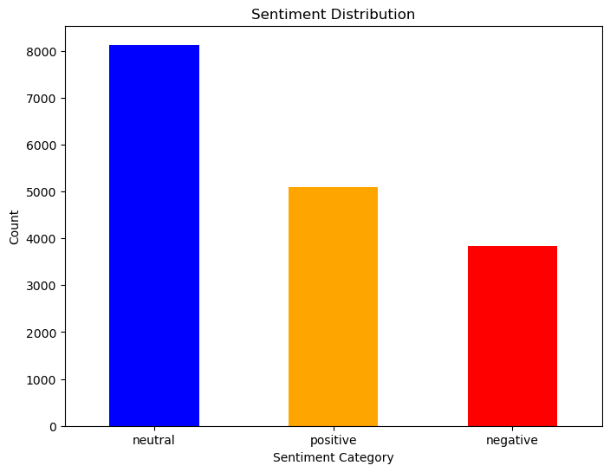

Figure 1:Sentiment Distribution (male activists)

Out of 17079 tweets, only 6349 found with label 1. Which shows male activists have tweets related to those five keywords. It’s also important, to know the tones of the individual keywords.

|  |  |  |  |
| --- | --- | --- | --- |
| Keywords | Negative | Neutral | Positive |
| Women | 519 (17.13%) | 1629 (53.76%) | 882 (29.11%) |
| Education | 229 (15.11%) | 631 (41.62%) | 656 (43.27%) |
| School | 346 (25.35%) | 648 (47.47%) | 371 (27.18%) |
| University | 121 (15.92%) | 432 (56.84%) | 207 (27.24%) |
| Girl | 504 (21.78%) | 1091 (47.15%) | 719 (31.07%) |

Table 2: Sentiment Analysis of Tweets Containing the Keyword (male activists)

Among male activists, each of the keywords is mostly couched in neutral tone. Education is much more positively expressed by most of the male tweeters. While school is mostly expressed in neutral tone, positive and negative sentiments about this word is relatively the same, meaning that support and disapproval for school is relatively the same. Table 4 shows, the average sentiment for each those five keywords.

|  |  |  |
| --- | --- | --- |
| Negative | Neutral | Positive |
| 49.37% | 31.57% | 19.06% |

Table 3: Average Sentiment Percentages (male activists)

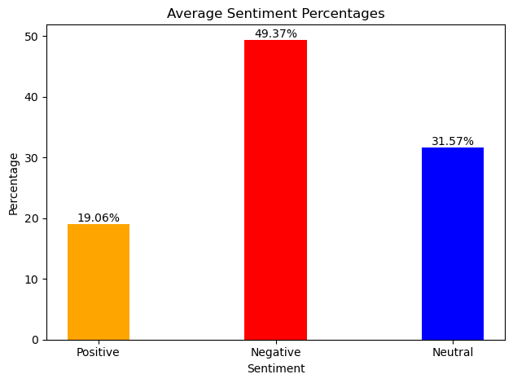

Figure 2: Average Sentiment Percentages (male activists)

To make the keywords narrow and more specific, we test only the “women education”, a total of 8 (9.1%) negative related to women’s education achieved followed the by neutral 52 (59.1%), and positive 28 (31.8%). This result shows that male activists have higher sentiment compare to the negative one, related to the women’s education.

|  |  |  |
| --- | --- | --- |
| Women Education | | |
| Negative | Neutral | Positive |
| 8 (9.1%) | 52 (59.1%) | 28 (31.8%) |
| Average | 0.0508% | |

Table 4: Average Sentiment Score for Women Education (male activists)

Tweets containing the term "women education" had a favorable response rate of 31.8%, a neutral response rate of 59.1%, and a negative response rate of 9.1%. These findings indicate that there is a fair amount of neutral emotion in addition to positive sentiment when it comes to women’s education. Indicative of the widespread optimism around female education, just a small percentage of tweets displayed a negative attitude. And an estimated average sentiment score of 0.0508% for all tweets in the sample indicates generally favorable attitude. This lends credence to the theory that male activists are more inclined to hold favorable views about women’s education.

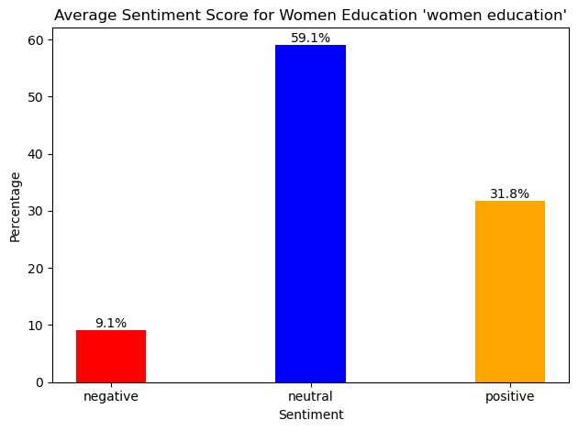

Figure 3: Average Sentiment Score for Women Education (male activists)

A collection of tweets was subjected to sentiment analysis, and the findings showed substantial mood shifts in comparison to the tweets themselves. A T-statistic of 13.798227652339987 and a p-value of 4.44754732493708e-43 were obtained from a comprehensive analysis of sentiment throughout the full dataset. There is a solid difference in sentiment between the total dataset and the tweets examined. It’s clear that there is a wide spectrum of emotions being discussed on Twitter, as the sentiment conveyed in the entire dataset is very different from the sentiment detected in the analyzed tweets. Then, we narrowed our attention to tweets that utilized terms like “women”, “education”, “school”, “university”, and “girl” to conduct a sentiment analysis. A T-statistic of 12.44785498860857 and an extremely small p-value of 3.6865531178524607e-35 were found when comparing the sentiment of these tweets with and without the use of the term. Compared to the general sentiment of the dataset, the tweets containing these keywords have a markedly different sentiment. The positive T-statistic value highlights the unique attitudes exhibited while addressing women, education, school, university, and girl, indicating that the sentiment conveyed in these tweets connected to the keywords differs significantly from the sentiment throughout the full dataset. We can that positive sentiments on keyword "women education" is significantly higher than the negative sentiments.

|  |  |  |  |
| --- | --- | --- | --- |
| Analysis of Sentiment Comparisons | | | |
|  | Whole Dataset | Label One (1) | Women Education |
| T-statistic | 13.798227652339987 | 12.44785498860857 | 2.5953068802040136 |
| P-value | 4.44754732493708e-43 | 3.6865531178524607e-35 | 0.011091143507551329 |

Table 5: Analysis of Sentiment Comparisons (male activists)

Furthermore, a specific focus was given to tweets specifically mentioning the keyword “women education”. The sentiment comparison for these tweets resulted in a T-statistic of 2.5953068802040136 and a p-value of 0.011091143507551329. Although the T-statistic is lower compared to the previous comparisons, the statistically significant p-value. This indicates a notable difference in sentiment compared to the overall dataset, suggesting that tweets discussing women's education express a sentiment that deviates from the sentiment found in the rest of the dataset.

|  |  |  |  |
| --- | --- | --- | --- |
| Analysis of Sentiment Comparisons | | | |
|  | Whole Dataset | Label One (1) | Women Education |
| T-statistic | 13.798227652339987 | 12.44785498860857 | 2.5953068802040136 |
| P-value | 4.44754732493708e-43 | 3.6865531178524607e-35 | 0.011091143507551329 |

Table 6: Analysis of Sentiment Comparisons (male activists)

We also used the chi-square test of independence to look at how "label" and "gender" are related, with an emphasis on the label "1". Label 1 is significantly associated with gender, according to the data. There was a large difference between the observed frequencies and those predicted by the independence assumption, as indicated by the chi-square value 53.57292547279976. Evidence like this points to a correlation between gender and the presence of label 1. To conclude, the data provide support for the hypothesis that a statistically significant correlation exists between gender and label 1. This suggests that the frequency with which or the proportion of the dataset containing label 1 is affected by gender.

The descriptive statistics sheds light on the typicality, core trend, and dispersion of opinions within male activists. Overall male sentiment is evaluated to be 0.0249 (mean), which is somewhat positive. This indicates that males, on average, have a more positive, according to the findings. The center value of the distribution, or the median emotion score, is 0.0 This means that, among males, 50% have a sentiment score over 0.0 and 50% have a score below 0.0. To get a sense of where most male stand emotionally, we may look at the median. There is a considerable amount of variation in men’s emotion ratings, as indicated by the standard deviation of 0.2357. This suggests that there is a wide range of emotions experienced by male in the sample. Understanding the sentiment distribution requires looking at the quartiles. Men’s opinion quartiles are [0.0, 0.0, 0.08625]. This indicates that 75% of the scores are below 0.08625, 25% are between 0.0 and 0.0, and 25% are below 0.0. A glimpse of the sentiment trends and distribution among males in the sample is provided by the descriptive statistics. While most males tend to be optimistic, there is a wide range of reported feelings from neutral to negative. These results help shed light on how attitudes have changed over time among men in the sample data.

The frequent words that found on male activists consists of "Taliban" appears 8,298 times in the tweets we analyzed; "Afghanistan" appears 3,386 times; "women" appears 3,297 times; "girl" appears 2,462 times; "Afghan" appears 1,948 times; "education" appears 1,510 times; "school" appears 1,466 times; "Kabul" appears 1,325 times; "Talibans" appears 1,103 times; and "people" appears 1,059 times. These phrases draw attention to the most common discussion points on Twitter and give essential background for grasping the underlying tone of users’ tweets.

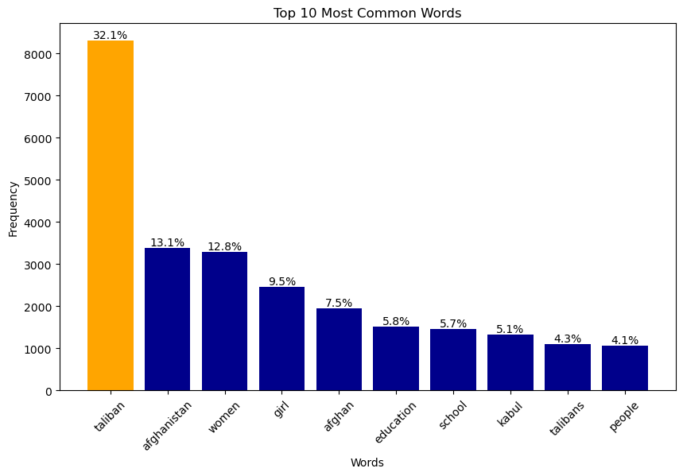

Figure 4: Most Frequent Words (male activists)

We conducted a detailed analysis of five specific keywords, namely “women”, “education”, “school”, “university”, and “girl”. The investigation aimed to understand the frequency of these keywords in tweets made by male activists since mid-2021. Figure 5 illustrates the usage trends of these keywords over the years, revealing a significant increase in their use in 2023. This suggests that male activists have been actively tweeting about education-related topics. The heightened frequency of tweets related to these keywords aligns with significant events that unfolded in 2021. Specifically, the Taliban regained power during this period (Maizland, 2023). Consequently, activists expressed their concerns by employing these specific keywords more frequently in their tweets. Moreover, in 2023, the Taliban implemented a complete ban on girls’ education and work (Kumar, 2023). This further fueled the activism, resulting in an increased usage of the aforementioned keywords in tweets. The findings highlight the proactive engagement of male activists in discussing and advocating for women’s education in the face of oppressive policies. The usage of these keywords serves as a reflection of the ongoing social and political context, indicating the efforts made by male activists to raise awareness and address the challenges faced by women in accessing education.

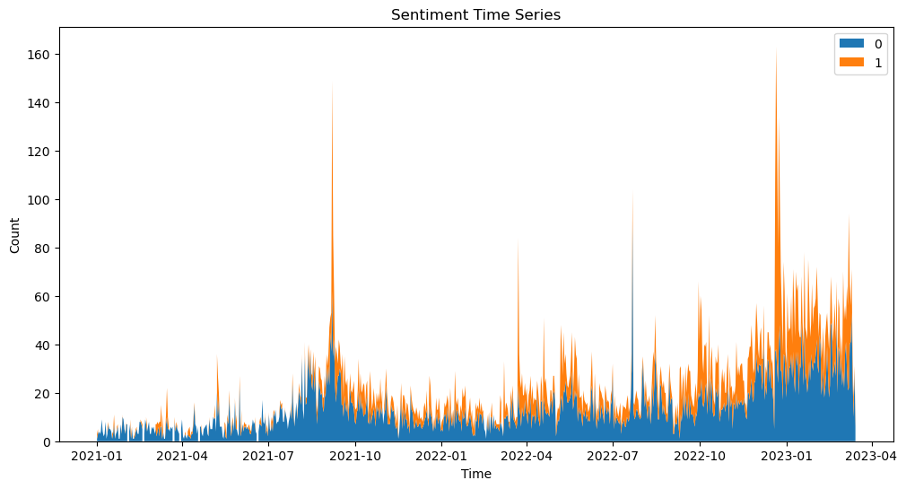

Figure 5: Time Series (male activists)

Understanding the frequency of tweets from male activists provides valuable insights into their engagement and response to critical issues. Figure 6 visually represents the fluctuations in tweet frequency, highlighting significant periods when male activists increased their tweeting activities. Notably, a surge in tweet frequency occurred in October 2021, which coincided with the period when the Taliban implemented restrictions on women's education. This increase in tweeting demonstrates the activists’ heightened concern and active involvement in advocating for women’s educational rights during this challenging time. Furthermore, another notable peak in tweet frequency occurred in 2023, indicating sustained activism and continued efforts to address the issues surrounding women’s education. The consistent engagement of male activists through their tweets underscores their dedication to raising awareness and advocating for positive change. By closely monitoring the tweeting patterns of male activists, we gain valuable insights into their collective response to the Taliban’s policies and their ongoing commitment to supporting women’s education. These tweets serve as an important medium through which activists express their concerns, amplify voices, and contribute to the larger discourse surrounding gender equality and educational opportunities.

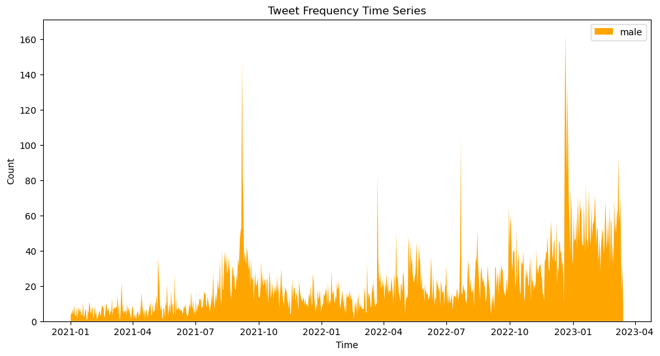

Figure 6: Tweet Frequency Time Series (male activists)

Word clouds display text data in different sizes based on frequency or importance. It quickly and intuitively finds a dataset’s most frequent terms or themes. Word clouds can show Twitter’s most popular words and topics. The dataset’s most frequent and essential words are displayed larger. Word clouds can help visualize Twitter’s top topics, trends, and discussions.

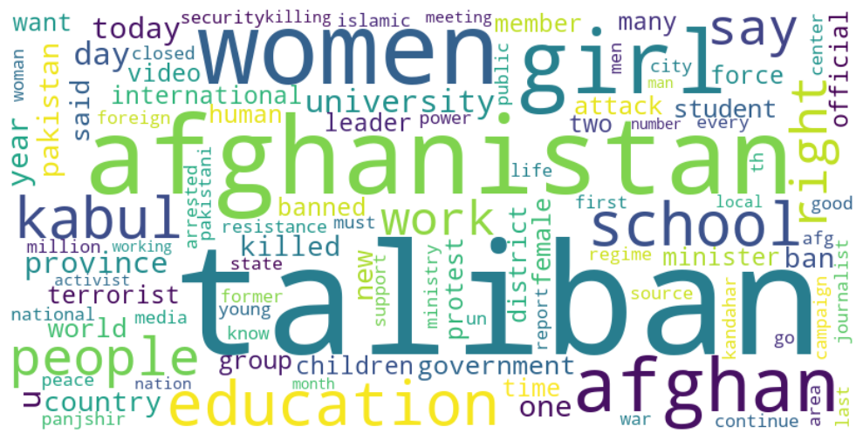

Figure 7: Word-cloud (male activists)

# Female Activists

Female activists’ views on women’s education will be examined in this section. Female activists’ opinions and sentiments are valuable in understanding support for women’s education since they advocate for women’s rights and empowerment. We analyze sentiment counts and distribution, text analysis, and statistical testing to understand female activists’ views on women’s education. This is section would the same as male activists but with different results, this data is based on female activists in Afghanistan. Female activists voiced neutral (13,582), positive (13,531), and negative (7,724) sentiments in 34,838 tweets, with a sample of 54 different accounts. Female activists were mostly impartial and favorable about different issues, including women’s education. And positive sentiment on women’s education: 38.8% (13,531) of the studied tweets were positive for women’s education. This shows that female activists value and promote women’s education.

|  |  |
| --- | --- |
| Unclean | Clean |
| Please support women education Afghanistan | please support women education afghanistan |
| Almost one Month since surrender Kabul Taliban banned women girl, work, media, sports, and Music Public | almost one month since surrender kabul taliban banned women girl work media sports music public |
| Unfortunately current problem women education work country serious sad twenty first century | unfortunately current problem women education work country serious sad twenty first century |
| Today, all universities reopened in Afghanistan after winter break, but ONLY for men. These brave young women are peacefully protesting outside Kabul University against Taliban BAN on women going to university. Let us amplify their voices! | today university reopened afghanistan winter break men brave young women peacefully protesting outside kabul university taliban ban women going university let us amplify voices |
| Taliban ban Afghan Women Education Basic Human Right Least World Could Ban Taliban | taliban ban afghan women education basic human rights least world could ban taliban |
| One month ago, The Taliban shut school gates for millions of Afghanistan girls — robbing them of not just an education but also their futures. Join me and add your name to the open letter calling on leaders to take urgent action and | one month ago taliban shut school gates millions afghanistan girl robbing education also futures join add name open letter calling leaders take urgent action |

Table 7: Tweet (female activists)

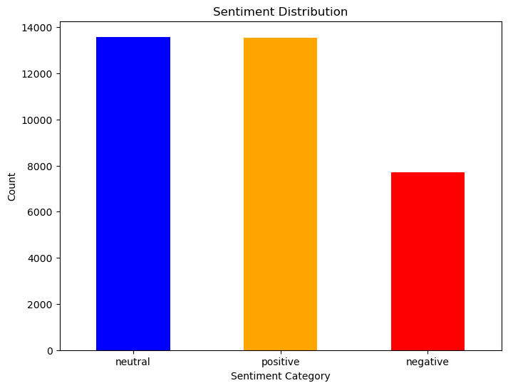

Figure 8: Sentiment Distribution (female activists)

The five keywords are more likely to use by female than males. Women used these terms more frequently than males did 13,615 times out of a total of 34,837 occurrences. This suggests that women are open to discussing women’s education on Twitter. Tweets containing these terms were analyzed for their overall tone: women, education, school, university, and girl. The sentiment related with instructional themes was uncovered by analyzing the sentiment distribution for each term. In each of these words, women mostly show neutral tone. Positive expression is larger than negative one.

|  |  |  |  |
| --- | --- | --- | --- |
| Keywords | Negative | Neutral | Positive |
| Women | 1677 (19.22%) | 3593 (41.17%) | 3457 (39.61%) |
| Education | 448 (20.25%) | 690 (31.19%) | 1074 (48.55%) |
| School | 636 (26.05%) | 976 (39.98%) | 829 (33.96%) |
| University | 198 (19.64%) | 442 (43.85%) | 368 (36.51%) |
| Girl | 1147 (23.29%) | 1953 (39.66%) | 1824 (37.04%) |

Table 8: Sentiment Analysis of Tweets Containing the Keyword (female activists)

Taking a closer look at the sentiment analysis of tweets discussing "women education," we find an interesting distribution. Among these tweets, 13.7% conveyed a negative sentiment, 46.3% had a neutral tone, and 40.0% expressed a positive sentiment. This suggests that while there were a significant number of tweets without a strong opinion, many female activists showcased their support for empowering women through education. When we compare these findings to the tweets from male activists, the results differ. Specifically, only 31.8% of the tweets related to "women education" were positive, while 59.1% remained neutral, and 9.1% displayed a negative sentiment.

|  |  |  |
| --- | --- | --- |
| Women Education | | |
| Negative | Neutral | Positive |
| 13 (13.7%) | 44 (46.3%) | 38 (40.0%) |
| Average | 0.0625% | |

Table 9: Average Sentiment Score for Women Education (female activists)

The computed t-statistic of 42.011 and p-value of 0.0 when comparing the sentiment of all tweets suggested a very significant difference in sentiment between these tweets. This shows that female activists' opinions differ significantly from one another. When we restricted our study to five keywords, we found a statistically significant difference in sentiment t-statistic of 28.321, p-value of 1.6955424742616196e-171. This suggests that female perspectives on women’s education were varied, with a leaning towards optimism.

The keyword "women education" was examined further, yielding a t-statistic of 3.432 and a p-value of 0.0008918697804590749. This demonstrated a substantial divergence of opinion among users of these keywords. As a result, even when narrowing the focus to only the term "women education," different emotions were displayed by female activists. The results show that there is a significant difference in tone among female activists' tweets. This suggests that feminist activists hold a wide variety of views, especially in regards to girls' and women's education. The investigation sheds light on the emotional dynamics at play in the online dialogues spearheaded by women activists, highlighting the need of education in achieving this goal.

|  |  |  |  |
| --- | --- | --- | --- |
| Analysis of Sentiment Comparisons | | | |
|  | Whole Dataset | Label One (1) | Women Education |
| T-statistic | 42.01121298491029 | 28.321068608930144 | 3.432135926285973 |
| P-value | 0.0 | 1.6955424742616196e-171 | 0.0008918697804590749 |

Table 10: Analysis of Sentiment Comparisons (female activists)

Female activists exhibited significantly higher support for education compared to male activists across all tweet categories. The sentiment analysis revealed substantial differences in sentiment between the two groups. In terms of overall tweets, female activists displayed a significantly stronger sentiment in favor of education t-statistic of 42.011, p-value of 0.0. This trend persisted when analyzing tweets related to entire dataset, using specific keywords for label one (1) t-statistic of 28.321, p-value of 1.6955424742616196e-171. Even within tweets containing the keyword "women education," female activists expressed a more positive sentiment, although to a lesser extent t-statistic of 3.432, p-value of 0.0008918697804590749. These findings highlight the consistent and robust support for education demonstrated by female activists, showcasing their dedicated advocacy for empowering women in educational contexts.

The top 10 frequent words in the tweet, shedding light on the prevailing themes and concerns related to women education. The word "Taliban" appears most frequently, indicating a significant focus on their activities and impact. This is followed closely by "women," highlighting the importance of discussing gender-related issues in the Afghan context. The occurrence of "Afghanistan" and "girl" further emphasizes the geographical and demographic aspects of the discussion. The presence of terms like "rights" and "education" underscores the ongoing struggle for human rights and the critical role of education in empowering individuals. Overall, the findings suggest a pressing need to address the challenges faced by Afghan women and girls, particularly in accessing education, while advocating for their rights and inclusion in Afghan society.

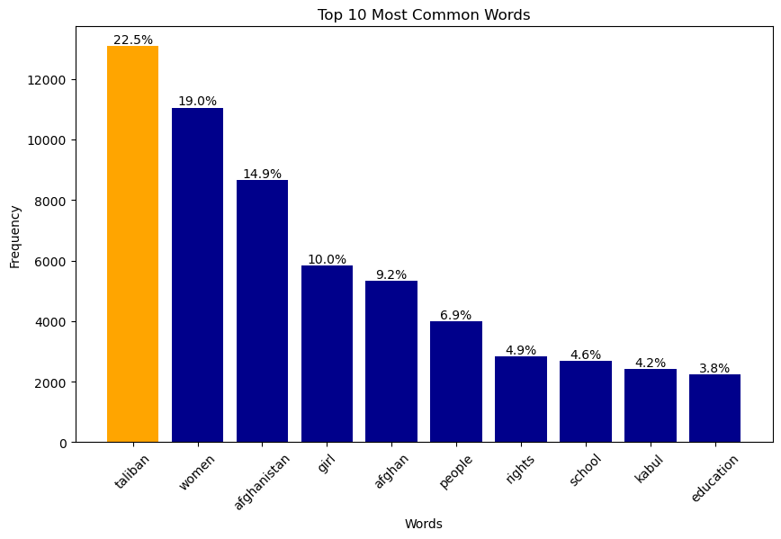

Figure 9: Frequent Words (female activists)

According to Figure 10, there has been a significant increase in the usage of five education-related keywords by female activists since 2021. In comparison to male activists, females have been consistently using these keywords more frequently, indicating their stronger support for education. Analyzing the data year by year, it becomes evident that women have consistently and noticeably used these keywords. This observation is particularly noteworthy because it coincides with the Taliban’s ban on women’s education in Afghanistan, which has likely contributed to the heightened usage of these keywords by women. The figure illustrates the substantial impact of this ban on the discourse surrounding education and highlights the determined efforts of female activists to advocate for educational rights in spite of the challenges they face.

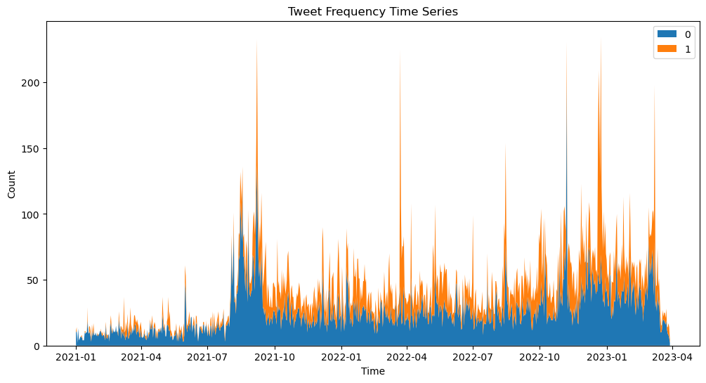

Figure 10: Time Series (female activists)

Understanding the frequency of activists’ tweets is a valuable aspect to consider, as it provides insights into their level of engagement and activity. Figure 11 presents the tweet frequency specifically for female activists. By comparing the tweet frequencies of male and female activists, it becomes evident that females are more likely to be active on Twitter. In the sampled data of 54 activists from both genders, male activists had a total of 17,079 tweets, whereas female activists had a significantly higher number of 34,837 tweets. This stark difference highlights the higher level of tweeting activity among female activists in the dataset.

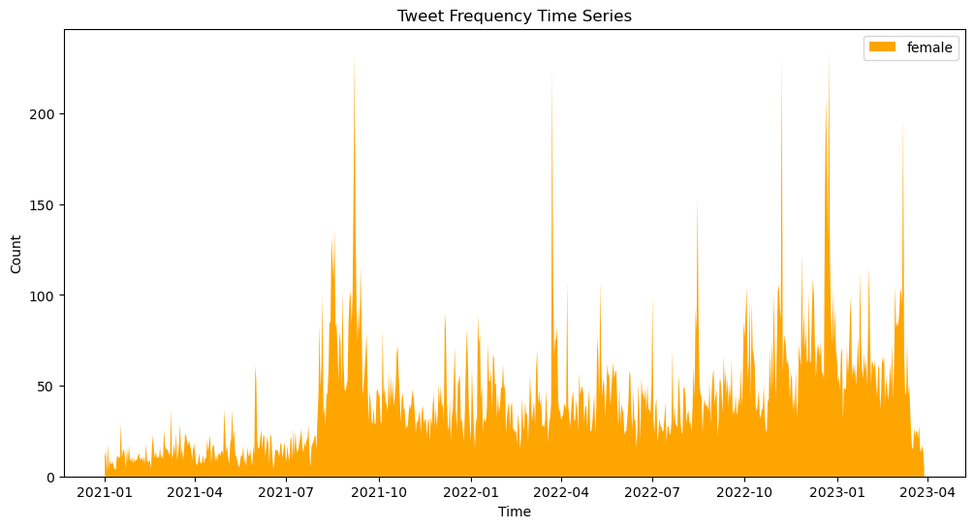

Figure 11: Tweet Frequency (female activists)

The word cloud-would show what people talked about most clearly. It would show prominently words like "Taliban," "Afghanistan," "Women," "Education," "Rights," "Girl," "School," "People," "Kabul," and "Afghan." These expressions conclude the fundamental ideas concerning the Taliban’s way, women’s rights, and education in Afghanistan. The word-cloud provides a visually interesting and understandable summary of the study key points.

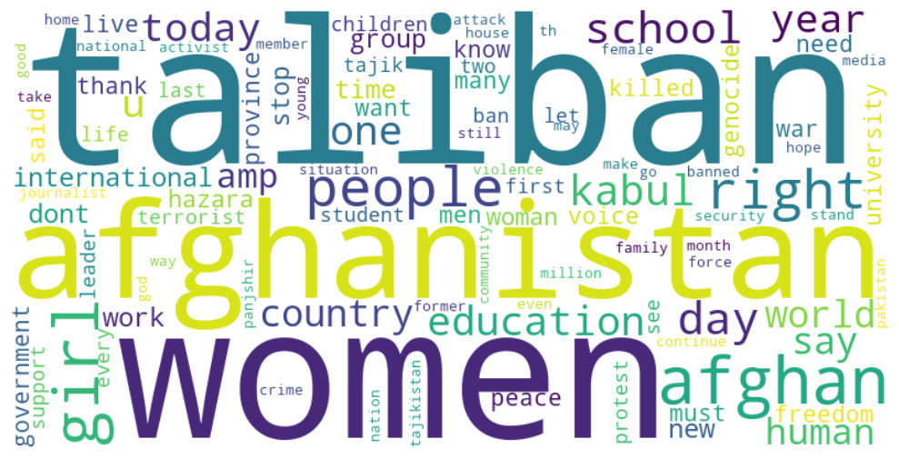

Figure 12: Word-cloud (female activists)

An intriguing discovery about women and education levels emerges from the logistic regression model analysis. The findings demonstrate a statistically significant correlation between the two factors. In particular, the coefficient for the 'sex' variable indicates that women are more likely to support women's education than men. This finding exemplifies the greater interest and enthusiasm for women's empowerment through education displayed by females. Female activists play a significant role in promoting and expanding women's education, and this highlights the significance of recognizing and addressing gender inequities in educational possibilities.

Optimization terminated successfully.

Current function value: 0.666075

Iterations 4

Logit Regression Results

==============================================================================

Dep. Variable: label No. Observations: 51916

Model: Logit Df Residuals: 51914

Method: MLE Df Model: 1

Date: Fri, 19 May 2023 Pseudo R-squ.: 0.0002553

Time: 00:26:46 Log-Likelihood: -34580.

converged: True LL-Null: -34589.

Covariance Type: nonrobust LLR p-value: 2.638e-05

==============================================================================

coef std err z P>|z| [0.025 0.975]

------------------------------------------------------------------------------

const -0.4439 0.011 -40.423 0.000 -0.465 -0.422

sex -0.0809 0.019 -4.198 0.000 -0.119 -0.043

==============================================================================

This section has been allocated to the Taliban’s officials, and the researcher has implemented the same procedure on the Taliban’s tweets. Earlier, we explained there is a single approach to find the Taliban’s account which is Zabihullah Mujahid, and Mobeen’s account. Both are famous and officially working with the Taliban and both has followed other Taliban, also, most of the Taliban has provided information about their positions on the government in their profile accounts. We have taken sample of 54 different Taliban interestingly we have found that Taliban are more likely be active on Twitter and frequently tweet. The total amount of tweets that we have received from 54 different accounts reached up to 78,316 after cleaning and removing noises. While on male and female activists significantly small tweets. The total amount of male activists are17,409, and female are 34,839, we can say that Taliban are more likely to tweet more frequently rather than the activists. To have insight about Taliban’s tweet we implemented the exact same method of sentiment analysis, and the results are, out of the total 78,316 tweets in the dataset, the sentiment analysis reveals that 35,029 are positive (44.72%), 26,637 are neutral (32.56%), and 16,672 are negative (22.71%). This suggests that the gathered tweets are overwhelmingly upbeat.

|  |  |
| --- | --- |
| Taliban Officials | respected maulvi abdul kabir also said islamic emirate want deprive women education allow go homes mentioned examples women girls actually engaged business education work offices hospitals |
| Taliban Officials | jobs allocated women educational sector today announced ministry education jobs teachers administrative staff male female states herat farah ghor badghis nangarhar laghman kunar Nuristan |
| Taliban Officials | public private universities throughout country open men women education process extended percent remaining parts country thousands women education higher education public health id passport offices airports police media |
| Taliban Officials | complete security educational centers redoubled efforts witness tragic events country sheikh maulvi nurullah mounir acting minister education |
| Taliban Officials | urgent justice provided perpetrators crime punished severely hereby express condolences families martyrs leadership ministry education therefore ask security agencies country identify perpetrators incident soon possible bring justice |

Table 14: Tweet (Taliban officials)

Table 12 shows the tweets related to women education, or at least regarding education. We did not find a certain tweet that says “women can educate” or “allow women to go to school”. Analyzing the tone of our keywords within Taliban’s tweet: Women, out of the 78,316 tweets, 545 tweets (66.27%) are positive, 353 tweets (42.98%) are neutral, and 281 tweets (34.18%) are negative. Education: Among the 1234 tweets containing the keyword ‘education,’ 232 tweets (18.81%) are negative, 262 tweets (21.23%) are neutral, and 1234 tweets (60.95%) are positive. School: For the 349 tweets containing the keyword ‘school,’ 173 tweets (49.57%) are negative, 168 tweets (48.14%) are neutral, and 349 tweets (2.29%) are positive. University: Among the 252 tweets containing the keyword ‘university,’ 77 tweets (30.56%) are negative, 158 tweets (62.70%) are neutral, and 252 tweets (6.73%) are positive. Girl: Out of the 467 tweets containing the keyword ‘girl,’ 223 tweets (47.74%) are negative, 125 tweets (26.76%) are neutral, and 119 tweets (25.50%) are positive.

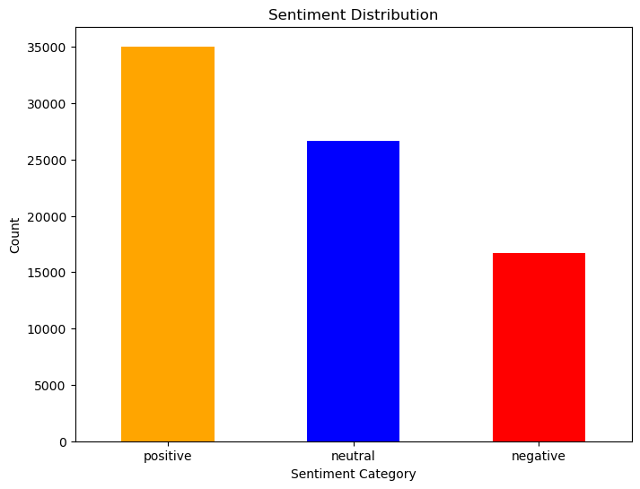

Figure 13: Sentiment Distribution (Taliban officials)

Sentiment Analysis of ‘Women Education’: When narrowing in on the term ‘women education,’ we discover that out of every 78,316 tweets, just three (or 25%) are directly related to the topic of women’s education. This suggests that the dataset gives less weight to the educational attainment of women. Analyzing the differences, when analyzing the difference in tone between Taliban tweets and non-Taliban tweets, we discover a statistically significant T-statistic of 88.73 and a P-value of 0.0. Comparison of opinions tweets about women’s education we discover a T-statistic of 1.51 and a P-value of 0.23 when we compare the opinions expressed by women and men on the topic of women’s education, indicating that there is no statistically significant difference in opinion.

A chi-square test of independence reveals no significant relationship between sentiment and either gender or the label relating to women’s education, with values of 0.0 and 1.0 for the chi-square and P =.10, respectively. When we look at the tweets from the Taliban users and cross-tab for sentiment and gender, we see that 16,672 tweets (45.51 percent) are negative, 26,637 tweets (72.33 percent) are neutral, and 35,029 tweets (95.70 percent) are positive. Furthermore, when we cross-tab sentiment and label (related to women’s education), we discover that out of 38,836 tweets, 3,836 tweets (9.87%) are classed as label 1. There are 3,836 tweets marked as 1 (5.15 percent) compared to 74,502 tweets marked as 0 (94.85 percent).

To go further and see the most top frequent words, Afghanistan appears on the top with 12,964, and followed by people. Table 13, shows the frequency of words in our dataset which belongs to the Taliban’s tweet.

|  |  |
| --- | --- |
| Word | Count |
| Afghanistan | 12,964 |
| People | 10,153 |
| Islamic | 9,381 |
| Minister | 7,325 |
| Country | 6,946 |
| Emirate | 6,858 |
| Ministry | 6,670 |
| God | 6,324 |
| Foreign | 5,933 |
| Said | 5,792 |

Table 15: Frequent Words (Taliban officials)

A picture is worth a thousand words, figure 12 shows, the frequent words with its percentage, the top repeated word is “Afghanistan,” which is 16.5% meanwhile, the words like, “education, women, school” did not appear on our top 10 words. This shows that activists are more likely to support education rather than the Taliban, the most frequent words on their dataset are education, schools, girls and Afghanistan.

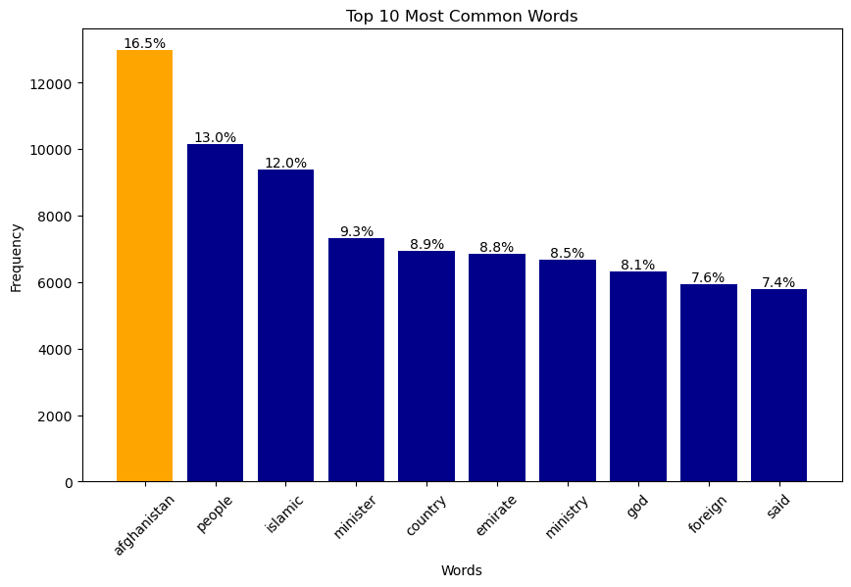

Figure 14: Frequent Words (Taliban officials)

Tweets from the Taliban have, on average, a slightly upbeat tone, as the descriptive statistics show a mean sentiment of 0.076. Since the median expression is neutral (0.0), positive and negative emotions appear to be equally distributed. There is substantial fluctuation in sentiment scores, with a standard deviation of 0.241. Half of the feelings fall below 0.0, and 75% fall below 0.183, with the quartiles spanning from 0.0 to 0.183.

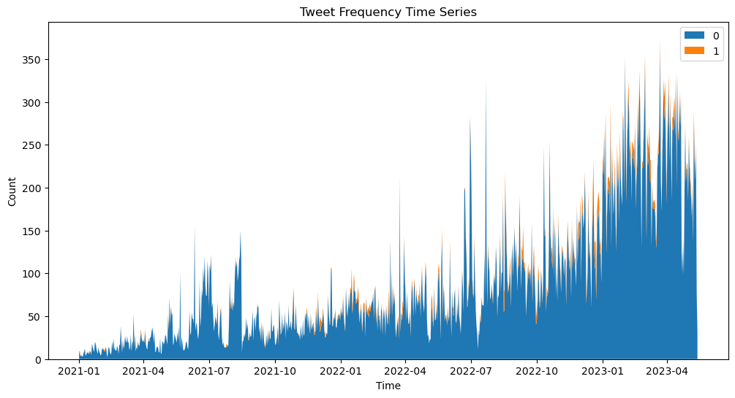

Figure 15: Time Series (Taliban official)

To compare all our time series figure, we would get a significant result, as the figure 13 show, all the areas are blue, it means there is no tweets which talks about those certain keywords which related to education and women. There slightly orange color, which I qualitatively added in table 12. We can summarize from their tweets that Taliban officials are less likely to tweet regarding women education or in another to support women’s education. This analyze is based on their tweets, which we have done it on activists as well. Last but not least, figure 14 shows the frequency of their tweets, figure shows that the Taliban as increase the number of tweets during the current year. Also, figure 15 shows the WordCloud.

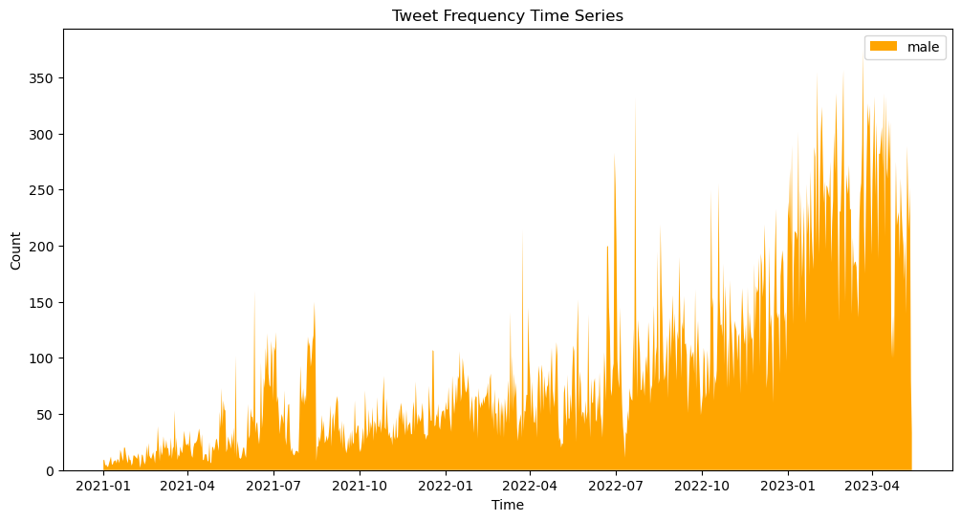

Figure 16: Tweet Frequency (Taliban officials)

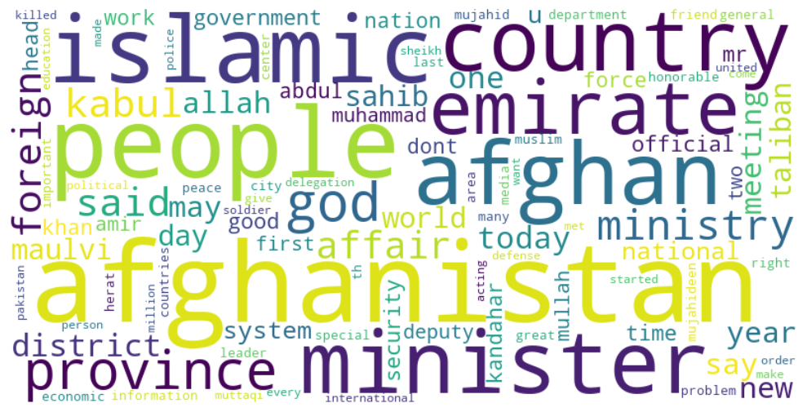

Figure 17: WordCloud (Taliban officials)

To conclude, examining tweets about women’s education reveals significant gender differences among advocates. Male activists are likely to remain emotionally neutral, whereas female activists are likely to lean positively. These results imply that gender dynamics and different priorities may contribute to differences in the degree of support and advocacy for women’s education among these activist groups. There is no statistically significant difference between the sentiment of Taliban tweets and the sentiment linked to women’s education, implying that the sentiment towards women’s education within the Taliban tweets is identical to their general mood.

# References

Evans, H. K., & Clark, J. (2015). “You Tweet Like a Girl!”: How Female Candidates Campaign on Twitter. *American Politics Research*, 10.

Kumar, R. (2023, February 24). *GOATS AND SODA*. Retrieved from GOATS AND SODA: https://www.npr.org/sections/goatsandsoda/2023/02/24/1158546120/the-taliban-ended-college-for-women-heres-how-afghan-women-are-defying-the-ban#:~:text=Since%20seizing%20power%20in%20August,high%20school%20since%20the%20takeover.

Lewis, D., & Burke, C. J. (1949). Categorical Data and Chi-Square Tests. *American Journal of Political Science*.

Maizland, L. (2023, January 19). *Council on Foreign Relations*. Retrieved from Council on Foreign Relations: https://www.cfr.org/backgrounder/taliban-afghanistan#:~:text=The%20Taliban%20returned%20to%20power,rights%20and%20neglected%20basic%20services.